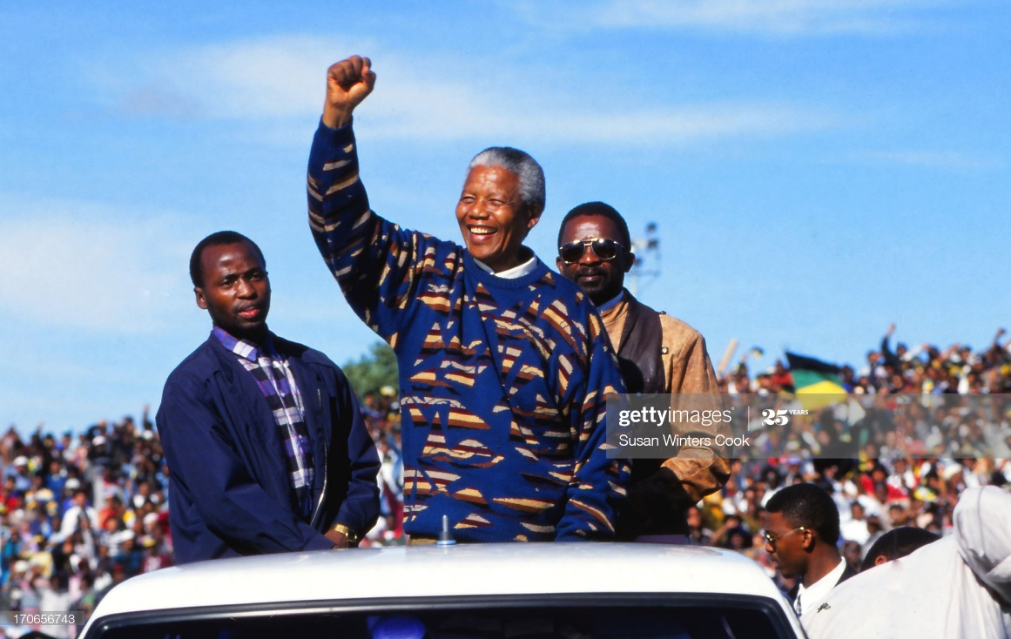
Nelson Mandela’s Speech on His Release from Prison On February 11 1990,
Nelson Mandela, after more than a quarter century behind bars, walked through the gates of Victor Verster Prison. Afterwards, he addressed the nation before a huge rally in Cape Town. The speech was broadcast live around the world. He was inaugurated president of South Africa in Pretoria on May 10, 1994.
Friends, comrades and fellow South Africans. I greet you all in the name of peace, democracy and freedom for all. I stand here before you not as a prophet but as a humble servant of you, the people. Your tireless and heroic sacrifices have made it possible for me to be here today. I therefore place the remaining years of my life in your hands. On this day of my release, I extend my sincere and warmest gratitude to the millions of my compatriots and those in every corner of the globe who have campaigned tirelessly for my release
Without your support our struggle would not have reached this advanced stage. The sacrifice of the frontline states will be remembered by South Africans forever. My salutations would be incomplete without expressing my deep appreciation for the strength given to me during my long and lonely years in prison by my beloved wife and family. I am convinced that your pain and suffering was far greater than my own
Today the majority of South Africans, black and white, recognise that apartheid has no future. It has to be ended by our own decisive mass action in order to build peace and security. The mass campaign of defiance and other actions of our organisation and people can only culminate in the establishment of democracy. The destruction caused by apartheid on our sub-continent is in- calculable. The fabric of family life of millions of my people has been shattered. Millions are homeless and unemployed. Our economy lies in ruins and our people are embroiled in political strife. Our resort to the armed struggle in 1960 with the formation of the military wing of the ANC, Umkhonto we Sizwe, was a purely defensive action against the violence of apartheid. The factors which necessitated the armed struggle still exist today. We have no option but to continue. We express the hope that a climate conducive to a negotiated settlement will be created soon so that there may no longer be the need for the armed struggle.
No individual leader is able to take on this enormous task on his own. It is our task as leaders to place our views before our organisation and to allow the democratic structures to decide. On the question of democratic practice, I feel duty bound to make the point that a leader of the movement is a person who has been democratically elected at a national conference. This is a principle which must be upheld without any exceptions.
There must be an end to white monopoly on political power and a fundamental restructuring of our political and economic systems to ensure that the inequalities of apartheid are addressed and our society thoroughly democratised. It must be added that Mr. De Klerk himself is a man of integrity who is acutely aware of the dangers of a public figure not honouring his undertakings.
Our struggle has reached a decisive moment. We call on our people to seize this moment so that the process towards democracy is rapid and uninterrupted. We have waited too long for our freedom. We can no longer wait. Now is the time to intensify the struggle on all fronts. To relax our efforts now would be a mistake which generations to come will not be able to forgive. The sight of freedom looming on the horizon should encourage us to redouble our efforts. It is only through disciplined mass action that our victory can be assured. We call on our white compatriots to join us in the shaping of a new South Africa. The freedom movement is a political home for you too.
We call on the international community to continue the campaign to isolate the apartheid regime. To lift sanctions now would be to run the risk of aborting the process towards the complete eradication of apartheid. Our march to freedom is irreversible. We must not allow fear to stand in our way. Universal suffrage on a common voters' role in a united democratic and non-racial South Africa is the only way to peace and racial harmony. In conclusion I wish to quote my own words during my trial in 1964. They are true today as they were then: 'I have fought against white domination and I have fought against black domination. I have cherished the ideal of a democratic and free society in which all persons live together in harmony and with equal opportunities. It is an ideal which I hope to live for and to achieve. But if needs be, it is an ideal for which I am prepared to die.'

